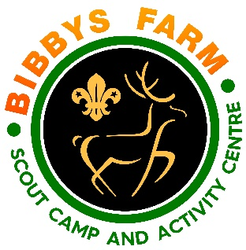
Activity: Bushcraft Completed by: Pete Sturgess Ref: SN.6/GBC1 Date: Dec 2023

Hazard | At Risk | Control Measures | Severity | Likelihood | Rating | Further Action
Burns from fire | Visitors | Bushcraft sessions usually involve fire-lighting or use of a fire for cooking. Leader in charge to brief participants about risk of burns and to agree protocols for minimising the risk of burns to those taking part. | 3 | 2 | 6 | Adequately Controlled
Food poisoning from undercooked food | Visitors | Leader in charge to ensure any raw meat is cooked thoroughly before participants eat any. Consideration given to using the method of simmering meat in a pan/tin of stock before eating to ensure it is fully cooked through | 2 | 2 | 4 | Adequately Controlled
Food poisoning from berries/fungi/plants | Visitors | Only leaders with the necessary skills to encourage eating any foraged food items to ensure that they are edible and not poisonous | 3 | 2 | 6 | Adequately Controlled
Cuts from knives | Visitors | If using knives for cutting meat or whittling wood, adequate instruction to be given first and close supervision to those using knives | 2 | 3 | 6 | Adequately Controlled
Illness from poor food hygiene | Visitors | Leader in charge to ensure that good hygiene is still essential even when cooking outdoors. All participants encouraged to wash hands before and after preparing food and use anti-bac spray when practical for surfaces. | 2 | 2 | 4 | Adequately Controlled
Transfer of infectious diseases such as COVID-19. Norovirus etc | Everyone | PPE such as masks and visors available upon request. Cleaning kits containing sanitising spray, paper wipes and hand gel available upon request.  Usage of above voluntary unless high rates when our procedures will require their use. | 3 | Low – 2  High - 3 | 6  9 | Adequately Controlled

