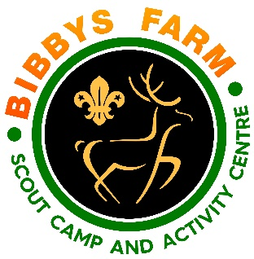
Ref. No. SN.6 / CCT1.1 Issue Date: Dec 2023
Climbing Tower
Hazard | At Risk | Control Measures | Severity | Likelihood | Rating | Further Action
Auto belay failure | Participants | - System checked prior to operation  - Weight limits for climbers to be observed  - Auto belays serviced annually | 2 | 1 | 2 | Adequately Controlled
Rope becoming tangled during the climb | Participants | - Auto Belay controls the slack during climbing and descent  - Opening inspection to check for correct operation  - Instructors to check tension for each climb  - Helmets should NOT be worn by participants | 2 | 1 | 2 | Adequately Controlled
Incorrect fitting of harness | Participants | - Instructor to check every harness for correct fit prior to or during clipping in. Consideration to be given for full body harnesses where appropriate eg by top heavy climbers. | 3 | 2 | 6 | Adequately Controlled
Poor Weather | Participants | - At the first sign of thunder and lightning the activity stops immediately.  The activity may continue 30 minutes after thunder is last heard.  - In strong winds (Yellow weather warning and above) wall to be taken down to prevent blowing over. | 1 | 4 | 4 | Adequately Controlled
Climber landing on someone during descent | All | - Instructor and current climbers to be the only ones allowed in the operating area. Barriers provided to keep people out of the way.  - Instructor to be aware of surroundings | 1 | 4 | 4 | Adequately Controlled
Group Behaviour | Participants | - If the group’s behaviour is dangerous the instructor will stop the session.  - Group leader must make sure their group is behaving well. | 1 | 2 | 2 | Adequately Controlled
Slips, trips and falls | Participants | - Participants warned about potential hazards.  - Participants are told not to run inside the activity area.  - All participants must be wearing sensible footwear (closed toe shoes).  - All equipment not being used will be put neatly to one side. | 1 | 1 | 1 | Adequately Controlled
Stuck or “Frozen” Climber | Participants | - Encourage climber to release and be lowered naturally by the auto-belay  - Lightweight climbers to be pulled down by the tracer line if fitted.  - Last resort, instructor climbs adjacent line to coax the climber down or fits tracer line to stuck climbers harness to pull them down manually | 1 | 4 | 4 | Adequately Controlled
Transfer of infectious diseases such as COVID-19. Norovirus etc | Everyone | PPE such as masks and visors available upon request. Cleaning kits containing sanitising spray, paper wipes and hand gel available upon request.  Usage of above voluntary unless high rates when our procedures will require their use. | 3 | Low – 2  High - 3 | 6  9 | Adequately Controlled

