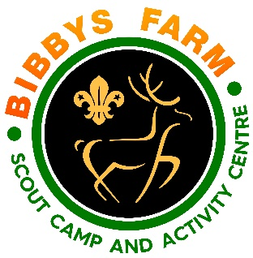
Crossbow
Hazard | At Risk | Control Measures | Severity | Likelihood | Rating | Further Action
Transfer of infectious diseases such as COVID-19. Norovirus etc | All | - PPE such as masks and visors available upon request. Cleaning kits containing sanitising spray, paper wipes and hand gel available upon request.  - Usage of above voluntary unless high rates when our procedures will require their use. | 3 | Low – 2  High - 3 | 6  9 | Adequately Controlled
Misuse of equipment | All | - Safety talk to include all rules of the range and safe shooting and handling of equipment at start of session and must contain information regarding the dangers of running on the range  - Adult in charge (instructor) to explain commands  - Adults to monitor behaviour closely and session stopped if required until safe to continue.  - No one to go over shooting line unless directed by activity leader and deemed safe.  - All non-shooting participants to wait in the designated waiting area.  • Range must be checked to ensure bolts cannot be shot out of the range (especially Outdoors, appropriate signs laid out.  - Overshoot area checked for people/animals prior to activity starting | 2 | 2 | 4 | Adequately Controlled
Impact from bolts | All | - Activity supervised at all times by NSRA YPS(Sport Crossbow) qualified instructor to ensure that the rules are complied with. | 2 | 2 | 4 | Adequately Controlled
General | All | - Only those participants that physically hold and shoot a crossbow to use this activity to avoid injuries  - Crossbows will be checked for safety before any use.  - When drawing back the string on a crossbow, care shall be taken to avoid injury to the back, arms and shoulders by following good manual handling practices.  - Bolts will only be offered to the string when the shooter is in position to shoot.  - Bolts shall only be loosed when aimed at the target and the target is clear.  - Crossbows shall never be transported when cocked or loaded. | 3 | 1 | 3 | Adequately Controlled
Horseplay | All | - Activity supervised at all times | 2 | 2 | 4 | Adequately Controlled
Unauthorised use | All | - All activity supervised at all times.  - When not in use then the equipment is secured. | 2 | 1 | 2 | Adequately Controlled
Impact from rear of bolt | All | Clear instructions given.  Participants supervised at all times. | 2 | 2 | 4 | Adequately Controlled
Slips, trips & falls | All | Area checked for hazards and a visual check made by the instructor at the beginning of the session. | 1 | 2 | 2 | Adequately Controlled
Equipment Failure | All | Equipment checked before use and regularly inspected and maintained. | 2 | 2 | 4 | Adequately Controlled
Checking equipment | Staff | Only staff trained to NSRA YPS (Sport Crossbow) standard to check equipment. | 1 | 2 | 2 | Adequately Controlled
Weather | All | Dynamic risk assessment conducted prior to activities start and continuously throughout the day.  Cross bows used in the activity barn range to avoid weather problems | 1 | 2 | 2 | Adequately Controlled

