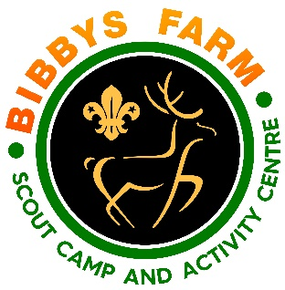
Ref: SN.6/GGS1 Issue Date: Dec 2023
Grass Sledges
Hazard | At Risk | Control Measures | Severity | Likelihood | Rating | Further Action
Injury through falling from sledge or collision with another person or object. | Camp site staff and volunteers, contractors, visitors and members of the public. | The activity must be supervised by a competent person.  Adult leaders to sign to agree to comply with operating procedures and risk assessment on receipt of equipment. | 3 | 2 | 6 | Adequately Controlled
Hazards on course | Users & spectators | Leader to check course for hazards before use and ensure spectators keep a safe distance from sledger | 2 | 1 | 2 | Adequately Controlled
Collision at end of course | Users | The end of the route must be clear of obstructions and the course is designed so that risk of overrun is minimised | 2 | 1 | 2 | Adequately Controlled
Running too quickly | Users | The specified course has a gradient that will allow descent at an appropriate speed for the age group participating. | 2 | 1 | 2 | Adequately Controlled
Malfunction | Users | Sledges provided are designed for purpose and are inspected for damage prior to every use by the supervising adult. Defective sledges withdrawn from use immediately and repaired & tested before being reintroduced to service. | 3 | 1 | 3 | Adequately Controlled
Transfer of infectious diseases such as COVID-19. Norovirus etc | Everyone | PPE such as masks and visors available upon request. Cleaning kits containing sanitising spray, paper wipes and hand gel available upon request.  Usage of above voluntary unless high rates when our procedures will require their use. | 3 | Low – 2  High - 3 | 6  9 | Adequately Controlled

