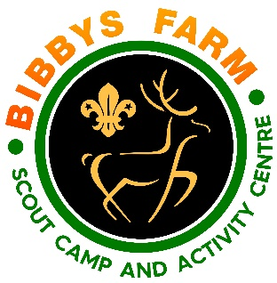
Hover Archery
Hazard | At Risk | Control Measures | Severity | Likelihood | Rating | Further Action
Transfer of infectious diseases such as COVID-19. Norovirus etc | All | - PPE such as masks and visors available upon request. Cleaning kits containing sanitising spray, paper wipes and hand gel available upon request.  - Usage of above voluntary unless high rates when our procedures will require their use. | 3 | Low – 2  High - 3 | 6  9 | Adequately Controlled
Normal hazards associated with hover archery | All involved in the session | Sessions to be run using Safety procedures.  Ensure suitable distance from shooting line to minimise bounce back. | 1 | 2 | 2 | Adequately Controlled
Unauthorised usage | Intruders | All archery equipment to be removed when not in use | 2 | 2 | 4 | Adequately Controlled
Hazards arising from the actions of group members i.e. Overcrowding or Disorderly behaviour. | All involved | The maximum ratio will be 1:10.  Only shooters and activity leader at the firing line.  Group leader must be present during sessions.  If group member’s behaviour becomes dangerous all spectators to be removed and or the activity must be ended. | 2 | 2 | 4 | Adequately Controlled
Injury due to equipment breaking and hitting participant  e.g. bruises, cuts and abrasions | All | - All equipment should be checked by the Adult in charge (instructor) prior to and during session.  - Regular / Monthly safety checks to be completed and logged.  - faults to be red tagged and reported | 3 | 2 | 6 | Adequately Controlled
Hazards arising from Instructor/staff | Participants | Over 18 to run session  Onsite briefing to be received before running a session  Operating procedures to be followed  Safety talk to include rules of the range and safe shooting and handling of equipment at start of session. | 3 | 2 | 6 | Adequately Controlled
Electrical shock | Users & staff | Fan unit to be checked for wear & tear, particularly the cable and any extension lead used to power the event.  Cable & blower not to be used in the rain or on wet surfaces | 3 | 1 | 3 | Adequately Controlled
Encroachment from non participants | All | - Adult in charge to be aware at all times of anyone approaching the range.  - Warning commands to be covered at start of session in safety talk  - If a person or animal moves towards or crosses the shooting area while archery is in progress, all archery must stop immediately. | 4 | 1 | 4 | Adequately Controlled

