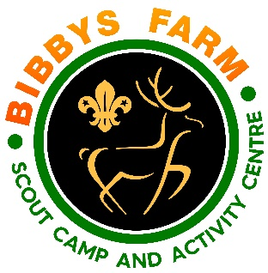
Nerf Guns

Hazard | At Risk | Control Measures | Severity | Likelihood | Rating | Further Action
Transfer of infectious diseases such as COVID-19. Norovirus etc | Everyone | - PPE such as masks and visors available upon request. Cleaning kits containing sanitising spray, paper wipes and hand gel available upon request.  - Usage of above voluntary unless high rates when our procedures will require their use. | 3 | Low – 2  High - 3 | 6  9 | Adequately Controlled
Slips, trips and falls | All | - Group control.  - Group instructed to be careful when moving around site.  - No running in the range.  - Range must be clear and the area clear of other equipment. | 2 | 2 | 4 | Adequately Controlled
Horseplay | All | - Activity to be supervised by an instructor, leader or Responsible adults.  - Session to be stopped if behaviour prevents the instructor effectively supervising the group. | 3 | 1 | 3 | Adequately Controlled
Nerfs rebounding | All | - Goggles are provided and should be worn by all participants.  - Nerfs are soft foam and safe to use  - Group size limited to 15 | 2 | 2 | 4 | Adequately controlled
Impact from Nerfs | All | - Range is enclosed and waiting area is behind the shooting line  - Nerfs are soft foam and safe to use  - Nerfs to be fired at targets only, not at each other. | 2 | 2 | 4 | Adequately Controlled
Unauthorised use | All | - Nerf guns in target sports locker when not in use.  - Nerf guns not to be left unattended | 4 | 1 | 4 | Adequately Controlled
Faulty equipment | All | - Equipment checked by staff when handed out and instruction on use given | 4 | 1 | 4 | Adequately Controlled

