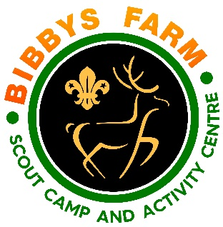
Issue Date: Dec 2023 Ref: SN.6/TTT2
Ninja (Soft)Tomahawk Throwing
Hazard | At Risk | Control Measures | Severity | Likelihood | Rating | Further Action
Transfer of infectious diseases such as COVID-19. Norovirus etc | Everyone | - PPE such as masks and visors available upon request. Cleaning kits containing sanitising spray, paper wipes and hand gel available upon request.  - Usage of above voluntary unless high rates when our procedures will require their use. | 3 | Low – 2  High - 3 | 6  9 | Adequately Controlled
Misuse of the equipment | all | - Instruction given and understood by participants before the activity takes place,  - activity supervised at all times by experienced adults.  - Ensure that the rules are complied with. | 3 | 1 | 3 | Adequately Controlled
Impact from axe | all | - Activity supervised at all times by a leader to ensure that the rules are complied with. Target bosses checked regularly | 4 | 1 | 4 | Adequately Controlled
Horseplay | all | - Activity supervised at all times by a leader and group leaders instructed that they are to ensure that their group complies with the operating rules and follow instructions given concerning waiting area, spectator line and shooting line.  - If horseplay is caried on after a warning the session will be stopped by the leader | 2 | 2 | 4 | Adequately Controlled
Unauthorised use | all | - Range is always supervised when in use, all equipment to be locked away when range unsupervised. | 3 | 1 | 3 | Adequately Controlled
Equipment failure | all | - Equipment checked before use. Any problems are logged. Equipment checked as per log book. Faulty equipment removed from service. | 2 | 2 | 4 | Adequately Controlled
Slips and Trips | all | Range checked before use. Participants encouraged to walk on range | 3 | 2 | 6 | Adequately Controlled

