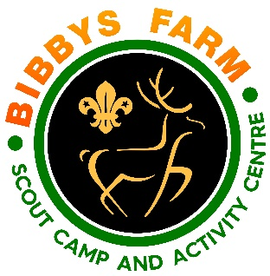
Ref: SN.6/GPG1 Issue Date: Dec 2023
Playground
Hazard | At Risk | Control Measures | Severity | Likelihood | Rating | Further Action
Falling from Height | Users | Ground covered with “Cushionfall” Play grade wood chippings to cushion any falls | 2 | 3 | 6 | Adequately Controlled
Falling onto foreign objects, glass, litter etc | Users | Playground regularly inspected for foreign objects & removed to prevent injury | 2 | 2 | 4 | Adequately Controlled
Standing or falling onto timber with protruding nails | Users | Bird Boxes no longer allowed in the playground as previously have fallen apart and left wood with protruding nails. | 3 | 2 | 6 | Adequately Controlled
Injury with no-one near to help | Users | Signs in place to insist upon adult supervision when playground in use | 2 | 2 | 4 | Adequately Controlled
Cuts from sharp metal | Users | All nuts & bolts on structures covered with plastic safety caps | 2 | 2 | 4 | Adequately Controlled
Digit entrapment | Users | All holes filled to prevent getting fingers stuck | 2 | 2 | 4 | Adequately Controlled
Equipment Failure | Users | Regular inspection regime to identify wear and tear and initiate repairs in a timely manner | 2 | 2 | 4 | Adequately Controlled
Being hit by swing | Users | Fences erected either side of swing to minimise people walking in front or behind of swing | 2 | 2 | 4 | Adequately Controlled
Transfer of infectious diseases such as COVID-19. Norovirus etc | Everyone | PPE such as masks and visors available upon request. Cleaning kits containing sanitising spray, paper wipes and hand gel available upon request. Hand Gel dispenser at entrance.  Usage of above voluntary unless high rates when our procedures will require their use. | 3 | Low – 2  High - 3 | 6  9 | Adequately Controlled

