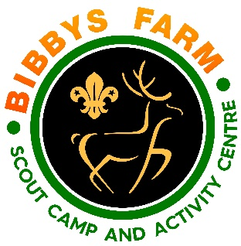
Ref: SN.6/GPY1 Date: Dec 2023
Pyrography
Hazard | At Risk | Control Measures | Severity | Likelihood | Rating | Further Action
Slips, trips and falls | All Participants | Group control. Group instructed to be careful when moving around site. No running in the area around the table. Be made aware of cables / plugs in the area. | 2 | 1 | 2 | Adequately Controlled
Horseplay | All Participants | Activity to be supervised by an instructor, leader or responsible adult.  Session to be stopped if behaviour prevents the instructor effectively supervising the group. | 3 | 1 | 3 | Adequately Controlled
Burnt fingers / hands | All Participants | Bucket of cold water or access to cold tap provided for use if burnt. Silicone Mitts available for use  Group size limited to 10. | 2 | 2 | 4 | Adequately Controlled
Tip Replacement & Woodburning Tool usage | All Participants | Activity to be supervised at all times.  Tips to be changed only when tool has completely cooled down. Tool heats up to 250 degrees | 2 | 2 | 4 | Adequately Controlled
Misuse of the equipment | All Participants | Wood-burning tools will be taken out of action if any tips bend or get damaged.  Tools must always be placed on the rest otherwise they will burn the surface. | 3 | 1 | 3 | Adequately Controlled
Unauthorised use | All Participants | Wood-burning tools and tips to be placed in a closed box and left in the reception. | 4 | 1 | 4 | Adequately Controlled
Transfer of infectious diseases such as COVID-19. Norovirus etc | Everyone | PPE such as masks and visors available upon request. Cleaning kits containing sanitising spray, paper wipes and hand gel available upon request.  Usage of above voluntary unless high rates when our procedures will require their use. | 3 | Low – 2  High - 3 | 6  9 | Adequately Controlled

