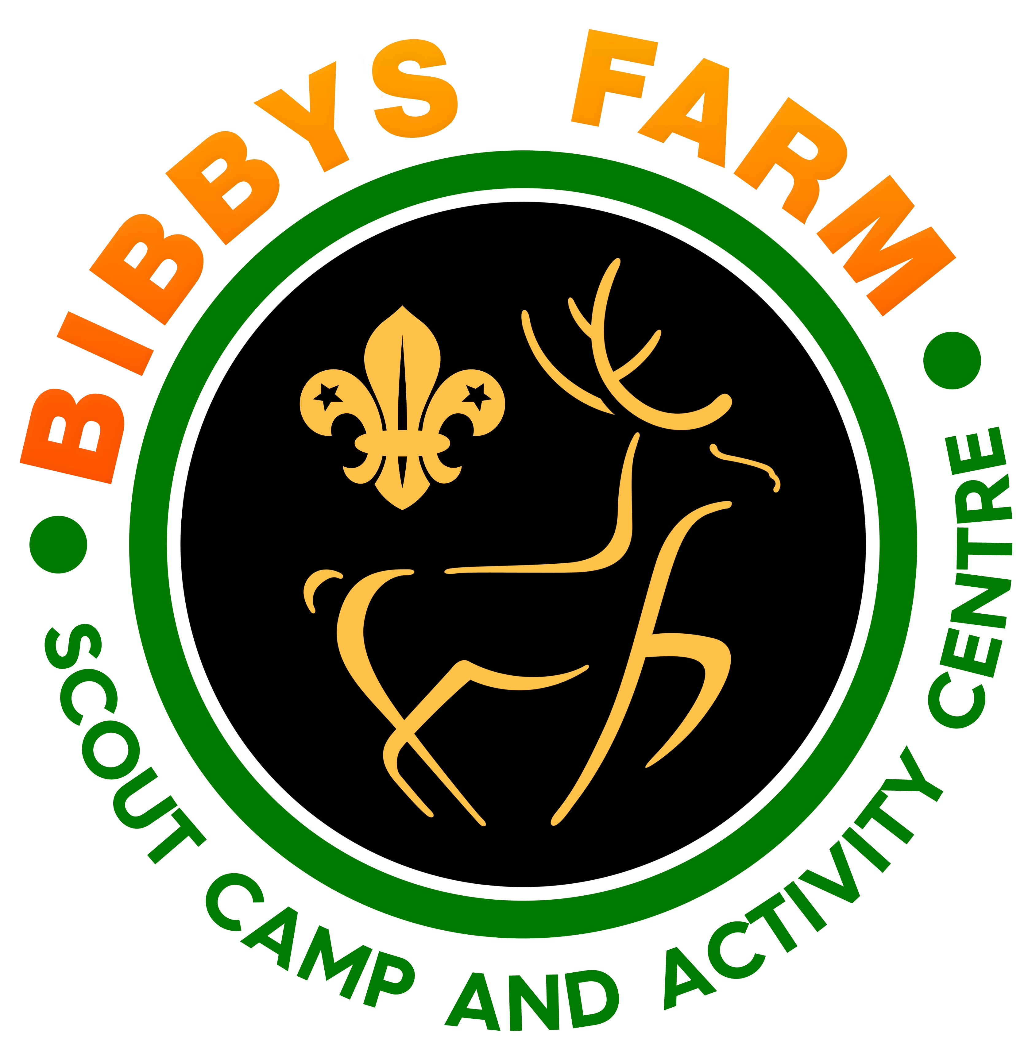Role Description – Site Caretaker – Bibbys Farm

The information given in this role description is intended to provide both role holder and managers with an understanding and appreciation of the workload of this particular job. The job description outlines main duties and responsibilities under broad headings only as it is not possible to specify every item in detail.

Overview: Volunteers developed the site since it was purchased in 2002. Since 2016, they have been supported by some paid staff. The role includes cleaning of buildings and site maintenance throughout the year.

RoleTitle: Site Caretaker based at Bibbys Farm

Working Hours: Full time or job-share
Flexible hours to suit the needs of the site; some evening and weekend work required.

Prime Objective of the Role

To ensure the facilities at Bibbys Farm are in a safe, clean and maintained condition and presentable for use as needed.

Line Management

Daily liaison with the Centre Manager but overall responsible to the Directors of Bibbys Farm.

Range of Duties
- Cleaning of site buildings
- Cleaning and keeping tidy all public areas
- Basic maintenance of buildings and public areas
- Working flexibly as part of the team at busy periods
- Using own initiative to highlight areas of concern needing maintenance or other attention
- Other similar duties as required from time to time.

Person Specification

Ability to work under own supervision with good time keeping Essential
Willingness to undertake an enhanced DBS Check Essential
Ability to work as a part of a team Essential
Ability to clean buildings to a high standard Essential
Practical hand on approach. Able to facilitate minor repairs Essential

Experience of working with volunteer teams Desirable
Knowledge/experience of Scouting and/or Guiding Desirable

Scouting experience preferable; must be prepared to join the join Scout Association if not already a member

Application

To apply for this role, please complete the application form and send by email or post to

Pete Sturgess, Centre Manager
Bibbys Farm Scout Camp Site & Activity Centre
Back Lane
Heath Charnock
Chorley
Lancashire
PR6 9DL

centre.manager@bibbysfarm.org.uk .

Closing date: 29 February 2024

Interviewees will be notified of a date in March for interview at Bibbys Farm. Please ensure that you complete the section in the application form setting out any dates in March when you are not available

