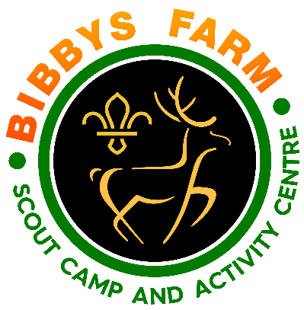***Activity Barn Press Release***

**“Popular, Local Scout Camp Site Awarded   
Funding for Major Building Project”**

The Bolton Scout Trust who run Bibbys Farm Scout Activity Centre has been awarded £250,000 towards replacing the Activity Barn at their centre based in Chorley.

Permissions were granted for the Activity Barn project when the site originally opened in 2005 and the recent grant award means that, along with existing reserves, the project can at long last make a start.

The existing Activity Barn was an old agricultural building converted into an indoor space for storage, shelter in poor weather and for the ability for the site to deliver activities such as climbing, archery and so on when the Lancashire weather is poor.

Over the coming months, our volunteers will be working to empty the existing building and create alternative activity locations ready for building to commence as soon as practical. It is anticipated that work could commence early in 2024 and potentially be completed within the year.

Bibbys Farm has an ambitious programme of training courses and events for you people that are hugely popular and that programme is currently being tweaked to ensure we can deliver as much as possible whilst working around the building programme required during the year.

Anyone interested in helping fund a specific part of the development like a new indoor climbing wall or other activities and facilities should contact Bibbys Farm direct on 0300 30 20 007 or e-mail centre.manager@bibbysfarm.org.uk

**Diane Hawkins, Chairman for the Bolton Scout Trust said:**

*“We are so pleased to receive this significant funding. We have had success with many funders in recent years but really struggled to fund the activity barn as it is such a large project. Finally we can take Bibbys Farm forwards to the next level in it’s evolution to provide better facilities for even more young people”*

**Pete Sturgess, Centre Manager for Bibbys Farm said:**

*“Over many years, our volunteers have coped with an activity barn that is in a quite poor state that doesn’t match the quality of their activity equipment or delivery of instruction. At long last, we will be able to bring the quality of this building up to match that of the rest of Bibbys Farm.*

**Notes to editors**

* Bibbys Farm Scout Camp Site and Activity Centre opened in May 2005 and has been a source of life-changing experiences for tens of thousands of young people ever since.
* Bibbys Farm is open to all youth organisations from Scouts & Guides to Youth Groups, Schools, Colleges and young people undertaking their Duke-of Edinburgh Award expeditions with over 30,000 young people visiting each year.

For Press-cleared images to use, please download from: <https://www.bibbysfarm.org.uk/press/>

For further information, please contact:

**Pete Sturgess**  
Centre Manager  
Bibbys Farm Scout Camp Site and Activity Centre  
Charnock Back Lane, Heath Charnock, Chorley, PR6 9DL

**Tel:**0300 30 20 007 **Mobile:**07792 540560 **Web:**[www.bibbysfarm.org.uk](http://www.bibbysfarm.org.uk/)  **Email:** [centre.manager@bibbysfarm.org.uk](mailto:centre.manager@bibbysfarm.org.uk)

**Twitter:**[@BibbysFarmScout](https://twitter.com/BibbysFarmScout) **Facebook:** [BibbysFarm](https://www.facebook.com/pages/Bibbys-Farm-Scout-Activity-Centre/102911323375670) **Youtube:** [BibbysFarm](https://www.youtube.com/channel/UC31l9b1WltkZhTgWuyMCG2Q)